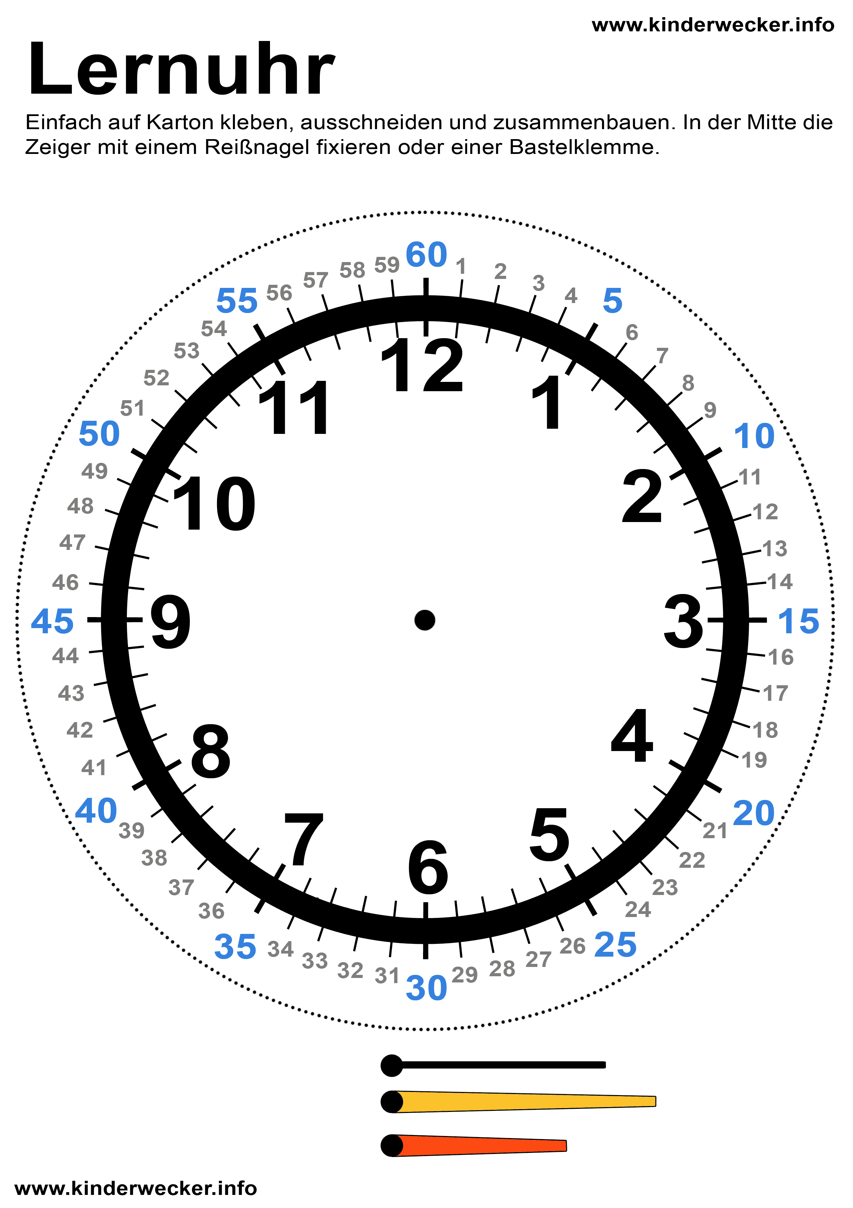

Sendeuhr

|  |  |
| --- | --- |
| Farbe | Art des Beitrags |
|  |  |
|  |  |
|  |  |
|  |  |
|  |  |
|  |  |